Name-Mukesh Kumar Yadav RollNo.-243528

Ans1-

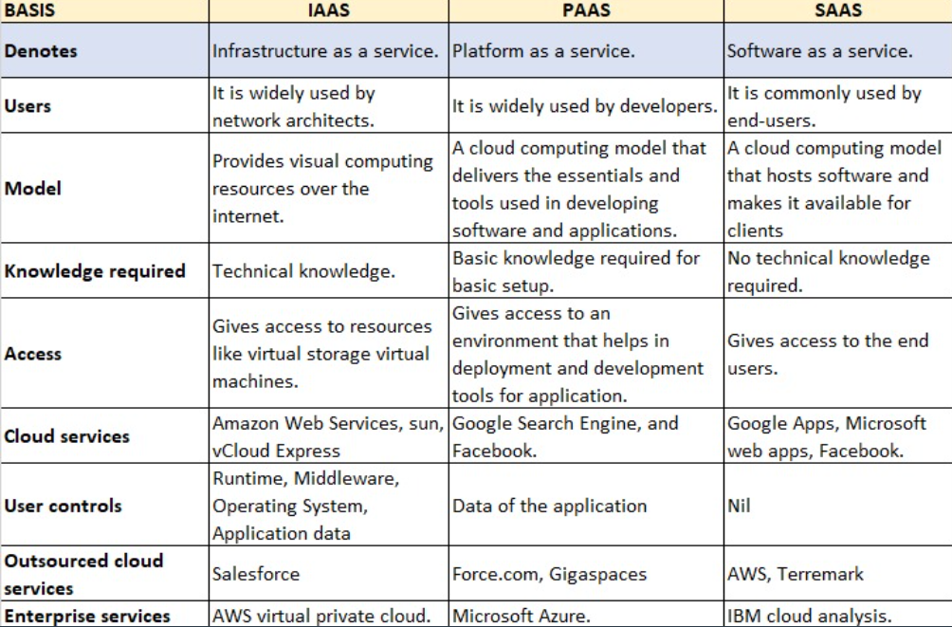

Ans-2

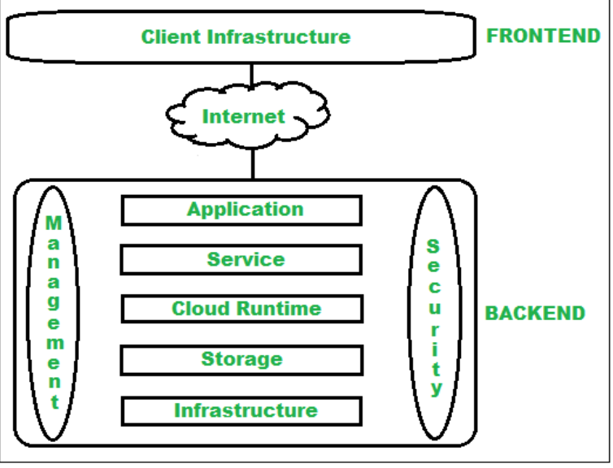

Ans-3 five services of AWS

**Amazon Elastic Cloud Compute (EC2)**

The Amazon EC2 Service is categorized under the computer domain, it implements the services that can help to estimate workloads. Amazon EC2 web interface is used to decrease the high-cost physical servers by designing virtual machines. They also help in maintaining the various features of a virtual server such as ports, storage, and security. While creating a virtual server, Amazon EC2 is highly preferable, and it provides the compute capability in the cloud. This supports a lot to concentrate more on the design rather than server maintenance.

**Amazon S3 (Simple Storage Service)**

Amazon S3 is classified under the storage domains, which stores the data in the cloud in the form of an object. Because of the enhanced infrastructure, this Amazon S3 has the capacity to store the data with high security. The data is divided into various physical regions and has a high-quality combination. Also, the data will not get dropped and it helps to recover the data via the Internet. Amazon S3 is extremely flexible that the user can get their data by one click.

**Amazon Virtual Private Cloud (VPC)**

Amazon VPC is categorized under the networking domain of AWS. It can be used to separate the network foundation of the user’s system. Each Amazon account operates an individual virtual network, which can protect the data from being accessed by others. This network is divided from another virtual network in AWS Cloud.

**Amazon CloudFront**

The Amazon CloudFront helps the delivery domains, which is usually used in delivering the content with high speed and decreased latency. Usually, the Amazon CloudFront connects the [**AWS**](https://www.fita.in/amazon-web-services-training-in-chennai/) Services to help the developers to transfer the content to the end-user in a smooth manner. Through the Global Content Delivery Service, the AWS CloudFront is efficiently managing all the user’s content.

**Amazon Relational Database Services (RDS)**

The Amazon RDS is classified under the Database domain of Amazon Web Services. It is used for managing the database workloads. The Amazon RDS can help the user to create and maintain the relational database in the cloud, that collects the complex data of the infrastructure. At the initial stage, the Amazon RDs support MySQL. Presently, it supports Oracle, MariaDB, and Microsoft [**SQL**](https://www.fita.in/sql-training-in-chennai/).

It decreases the cost of operation and leverages the database server from maintenance and support.

FIVE SERVICES OF GCP

1. **Google Compute Engine:** This is the Infrastructure as a Service (IaaS) component of Google Cloud Platform, powering Google’s own services like search, Gmail, and YouTube. It allows users to launch virtual machines on demand.

* **Google App Engine:** This platform lets you create and host applications on the same infrastructure that Google uses.
* **Google Kubernetes Engine:** This service provides a managed environment for deploying, managing, and scaling your containerized applications using Google’s infrastructure.
* **Google Cloud Container Registry:** This service is designed for storing private container images. It offers a subset of the features available in Artifact Registry, which is the recommended service for managing container images and other artifacts in Google Cloud service.
* **Cloud Functions:** It provides the ability to access computer resources, including data storage and processing power, on-demand, without requiring active management from the user.

1. **Networking**

* **Google Virtual Private Cloud (VPC):** This manages virtual machines, Kubernetes clusters, and flexible environments, allowing you to access cloud resources worldwide in a flexible and scalable manner.
* **Google Cloud Load Balancing:** It’s a distributed, software-defined service that helps distribute internet traffic efficiently, built on the same infrastructure used by Google App Engine.
* **Content Delivery Network:** Google Cloud CDN speeds up website content delivery by caching it close to users, thanks to Google’s global network of data centers.
* **Google Cloud Connect:** This free plugin lets you easily store and sync Microsoft Office documents with Google Docs in various formats.
* **Google Cloud DNS:** It’s a high-performance, global DNS service for managing and publishing DNS records for your applications and Google Cloud service.

1. **Storage and Databases**

* **Google Cloud Storage:** This is a web service for storing and accessing data on Google Cloud Platform.
* **Cloud SQL:** It’s a fully managed database service that simplifies database management.
* **Cloud Bigtable:** A service for managing large-scale structured data.
* **Google Cloud Datastore:** A highly scalable NoSQL database service.
* **Persistent Disk:** These are network storage devices that your virtual machines can use just like physical disks.

1. **Big Data**

* **Google BigQuery:** It’s a fully managed data warehouse that enables analytics on massive datasets.
* **Google Cloud Dataproc:** A managed service for running various data processing tools and frameworks.
* **Google Cloud DataLab:** A powerful tool for data analysis and pattern finding, integrated with Cloud Storage and BigQuery.
* **Google Cloud Pub/Sub:** This service facilitates messaging between applications, ensuring reliable communication.

1. **Identity and Security**

* **Cloud Resource Manager:** It helps you organize and manage GCP resources within containers such as Organizations, Folders, and Projects.
* **Cloud IAM:** This service allows administrators to control who can perform actions on specific resources, enhancing resource management.
* **Cloud Security Scanner:** It identifies security vulnerabilities in web applications on App Engine, Kubernetes Engine, and Compute Engine.
* **Cloud Platform Security:** This involves practices and technologies to safeguard enterprise security against internal and external threats.

FIVE SERVICES OFFERED BY AZURE

Azure Cosmos DB Free Tier

With its industry leading features and highly accessible engineering team, Azure Cosmos DB remains one of the most popular services in Microsoft’s cloud. What could be better? How about a free tier! Azure Cosmos DB Free Tier gives you 400 RUs and 5 GB of storage, making it perfect for dev/test environments, proof-of-concepts, and even smaller production workloads. The free tier is fully featured but limited to one instance per subscription and any overages of RUs or storage are billed at normal rates. To get started with your own completely free Cosmos DB instance, [check out this link](https://docs.microsoft.com/en-us/azure/cosmos-db/optimize-dev-test#azure-cosmos-db-free-tier).

Azure Resource Health Alerts

Embedded within the Azure Service Health suite of services you’ll find Azure Resource Health Alerts. This service provides a near real-time availability signal representing the health of your deployed Azure resources. Over [42 resource types](https://docs.microsoft.com/en-us/azure/service-health/resource-health-checks-resource-types) are supporting including all of the most common types like virtual machines, storage accounts, web apps, and SQL databases. These alerts, along with action groups, make sending production down SMS/email notifications or building a near real-time availability dashboard trivial. At the time of this writing, Azure Resource Health is in preview and requires programmatic use of an [ARM template and powershell command](https://docs.microsoft.com/en-us/azure/service-health/resource-health-alert-arm-template-guide) to create them with in subscription or resource group.

Azure Private Link

For enterprise customers, particularly banks, insurance, healthcare and government agencies, Azure PaaS services are often a non-starter due to public IP addresses. [Azure Private Link](https://azure.microsoft.com/en-us/services/private-link/#product-overview) solves this problem keeping data over Azure networking backbone by providing a private IP address from your VNet, effectively bringing the PaaS service into your VNet. Private link works across Azure regions and is now generally available to work with PaaS services such as AKS, Cosmos DB, SQL Database, KeyVault and more.

Azure Advisor Recommendations

Azure Advisor is a free service that analyzes Azure resources in the subscription and provides recommendations to optimize resources in areas of cost, security, availability, performance and operational excellence. The recommendations have been growing and help to –

* [Lower](https://docs.microsoft.com/en-us/azure/advisor/advisor-cost-recommendations) the Azure spend by identifying underutilized resources, recommending purchase of Reserved Instances, right tiers for your Azure blob storage etc.
* Improve the [availability](https://docs.microsoft.com/en-us/azure/advisor/advisor-high-availability-recommendations) by identifying virtual machines, availability sets, application gateway that do not have fault tolerance configured, providing recommendations against accidental deletion of virtual machines, storage account, identifying non-partitioned collections that are reaching their provisioned storage quota
* [Secure](https://docs.microsoft.com/en-us/azure/advisor/advisor-security-recommendations) Azure resources by acting on recommendations provided by Azure Security Center on any vulnerabilities identified. Azure Security Center Free Tier helps you protect your Azure VMs and VMSS, providing continuous assessment and security recommendations. To protect on-prem resources, and also enable threat protection for Azure VMs, non-Azure Servers, and PaaS services, you can upgrade to [Standard Tier](https://docs.microsoft.com/en-us/azure/security-center/security-center-onboarding#next-steps).
* Improve the speed and [performance](https://docs.microsoft.com/en-us/azure/advisor/advisor-performance-recommendations) of your applications by getting recommendations on performance for Storage accounts SQL Azure Database, Azure My SQL, Azure PostgreSQL, Azure MariaDB, and Cosmos DB, scaling caching, and improving app service performance and availability.
* Achieve [operational excellence](https://docs.microsoft.com/en-us/azure/advisor/advisor-operational-excellence-recommendations) through recommendation focused on creating Azure Service Health alerts, best practices using Azure Policy.

To better manage recommendations, add Advisor [recommendation digests](https://docs.microsoft.com/en-us/azure/advisor/advisor-recommendations-digest) so that you can get a summary of active recommendations across different categories for a subscription periodically through email or other ways by configuring [Action Groups](https://docs.microsoft.com/en-us/azure/azure-monitor/platform/action-groups).

Azure Arc

For your Azure deployments, you already use Azure portal, Azure Cloud shell, Azure API to manage your resources. Now with [Azure Arc](https://azure.microsoft.com/en-us/services/azure-arc/), you can extend these capabilities to manage resources in hybrid environments such as datacenters, private, public clouds and the edge. Azure Arc can help with management and governance of servers and Kubernetes clusters across environments with a unified view in Azure Portal and API. Azure Arc also enables you to enforce compliance by centrally managing access and security policies with standardized Role Based Access Control. Azure Arc is in preview now, so there is no cost to trying it [out](https://docs.microsoft.com/en-us/azure/azure-arc/servers/onboard-portal)

ANS-4 DIFFERENCES AND COMAPRISON BETWEEN THE SERVICES OF CLOUDS.

|  | **AWS** | **Azure** | **Google Cloud** |
| --- | --- | --- | --- |
| Suite of services | 200+ | 200+ | 100+ |
| Cloud regions | 31 | 60+ | 37 |
| Availability zones | 99 | 3 per region | 112 |
| Global coverage | 245 countries and territories | 140 countries | 200+ countries and territories |
| Compliance offerings | 143 (including security standards) | 100+ | 100+ |
| Compute | Amazon Elastic Compute Cloud | Azure Virtual Machines, Azure Container Instances, Azure App Service, etc | Google Compute Engine |
| Relational and non-relational databases | 15 | 10 | 9 |
| Storage | Simple Storage Service | Azure Blob Storage | Cloud Storage |
| Hybrid and multi-cloud strategy support | AWS Outposts | Azure Stack | Anthos |
| IoT | AWS IoT Core | Azure IoT Hub | Cloud IoT Core |
| Serverless functionality | AWS Lambda | Azure Functions | Cloud Run |
| Key AI/ML offerings | Amazon SageMaker, Amazon Augmented AI, Amazon Forecast, Amazon Personalize, etc | Applied AI Services, Amazon Bot Services, Azure Cognitive Services, Anomaly Detector, Kinect DK, etc | Vertex AI, Speech-to-Text, Text-to-Speech, Translation AI, Dialogflow, etc |
| Pricing | - Pay-as-you-go model - Free account + 12-month Free Tier offers for newcomers | - Pay-as-you-go model - Free account + $200 credit to spend in the first 30 days after signing up + 55+ free services for 12 months - 40+ services are always free | - Pay-as-you-go model - Free account + $300 credit to spend - 20+ free products for all customers |